ONLINE COURSE MARKETPLACE
@CREATIVITY THINK (9483175986/7019689991)

ABSTRACT:
Online Course Marketplace is a web application designed to centralize online learning by offering course browsing, purchase/enrollment, progress tracking, reviews, and analytics dashboards. Learners can explore available courses, enroll, monitor their progress, and provide ratings. Administrators manage courses, monitor learner progress, and analyze engagement through dashboards. Using Django and Django Rest Framework for the backend and React, Redux, and Recharts for the frontend, this platform enhances learning accessibility, provides real-time progress analytics, and ensures structured course management, catering to students, tutors, and DIY learners efficiently..

INTRODUCTION OF THE PROJECT:
The Online Course Marketplace addresses the growing demand for accessible, structured, and interactive online learning. Learners can explore course catalogs, enroll in courses, track their progress, and provide feedback or reviews. Administrators and instructors gain control over course content, learner management, and analytics dashboards. The system leverages Django and DRF for secure backend processing and React, Redux, and Recharts for responsive front-end interfaces and interactive data visualization. The platform is ideal for educational institutions, private tutors, and self-learners seeking streamlined access to courses and performance tracking..

PROJECT OBJECTIVES:

• Centralize course listing and online enrollment
• Allow learners to track progress and performance metrics
• Enable course reviews and learner feedback
• Facilitate secure payment and enrollment processes
• Provide administrators with tools to add/edit courses
• Monitor learner engagement and progress via dashboards
• Generate analytics for course popularity and performance
• Improve accessibility to online learning for diverse users

PROBLEM OF THE STATEMENT:
Traditional learning platforms often lack centralized course management, progress tracking, and real-time analytics. Learners struggle to monitor their learning journeys, and instructors find it challenging to assess engagement and performance efficiently. This project solves these problems by offering a structured online course marketplace with interactive dashboards, real-time progress tracking, and analytics for both learners and administrators, enhancing course accessibility and management..

MOTIVATION OF THE PROJECT:
• Facilitate access to online courses for learners globally
• Track learning progress efficiently for users and admins
• Centralize course management and analytics for instructors
• Encourage learner engagement with progress tracking and reviews
• Provide actionable insights for course improvement and administration

BLOCK DAIGRAM OF PROJECT:

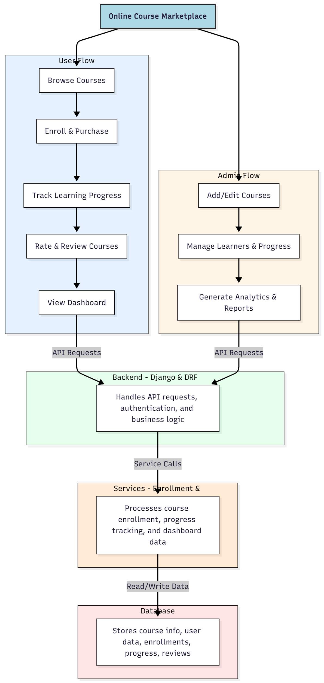

WORKING OF THE PROJECT:
Users browse available courses and select courses to purchase and enroll. They track their learning progress, submit reviews and ratings, and access personalized dashboards displaying progress and achievements. The backend handles API requests, authentication, and business logic, while the services layer manages course enrollment, progress tracking, and analytics data. Administrators add and edit courses, manage learner data and progress, and generate analytical reports to monitor engagement and performance. The system provides a seamless, interactive learning and management experience for users and admins..

SOFTWARE REQUIREMENT:
- Backend:
  - Python 3.x
  - Django
  - Django REST Framework
  - SQLite/PostgreSQL
- Frontend:
  - Node.js and npm
  - React.js
  - Axios
- Development Tools:
  - Visual Studio Code
  - Postman (for testing APIs)
  - Git/GitHub (for version control)
- Server/Deployment (Optional):
  - Gunicorn, Nginx, or Heroku/AWS for hosting

ADVANTAGES OF THE PROJECT:

• Centralized online course management for learners and admins
• Track learning progress in real time
• Interactive dashboards for users and administrators
• Secure enrollment and purchase processing
• Learner feedback through course reviews and ratings
• Analytics for engagement and performance tracking
• Scalable platform for diverse courses and learners
• Improves accessibility and quality of online learning

APPLICATIONS OF THE PROJECT:
• Online education platforms
• Tutoring services and coaching centers
• DIY learning communities
• Corporate training and upskilling programs
• MOOCs and e-learning aggregators
• Student progress tracking for schools and colleges
• Instructor-led online courses
• Data-driven curriculum improvement and analytics

REFERENCES:

- Django REST Framework Documentation — Django Software Foundation. Django Documentation. Available: https://docs.djangoproject.com/
- Django REST Framework. DRF Documentation. Available: https://www.django-rest-framework.org/
- React. React Official Documentation. Available: https://reactjs.org/docs/getting-started.html
- Redux. Redux Documentation. Available: https://redux.js.org/introduction/getting-started
- PostgreSQL Global Development Group. PostgreSQL Documentation. Available: https://www.postgresql.org/docs/
- MySQL. MySQL Reference Manual. Available: https://dev.mysql.com/doc/
- Git. Git Documentation. Available: https://git-scm.com/doc
- Node.js. Node.js Documentation. Available: https://nodejs.org/en/docs/
- Axios. Axios Documentation. Available: https://axios-http.com/docs/intro
- Socket.io Documentation – https://socket.io/docs/

